Microsoft WF Azure Activity Pack

CTP 1 Sample

Table of Contents

Introduction 2

Roles Definition 2

Workflow Diagrams 2

Service Configurations 3

Configurations for Windows Azure Storage Service 3

Configurations for Windows Azure AppFabric Caching Service 4

Walkthrough 5

# Introduction

The sample for Microsoft WF Azure Activity Pack CTP 1 is a simple application for users to upload a file, and view all file entities available in the system. The sample solution is created from the template of Windows Azure Project.

## Roles Definition

* **UIWebRole** (ASP.NET MVC)
  + An ASP.NET MVC website interacts with end-users.
  + The user can view the file list retrieved from both Azure Table and Azure Caching.
* **WFWebRole** (WCF Workflow Service)
  + A WCF Workflow Service is responsible for inserting / updating a file entity to Azure Table. UIWebRole interacts with this service asynchronously.
* **WFWorkerRole** (Workflow Application)
  + A long-running workflow monitors newly inserted / updated file entities in Azure Table, and pushes the latest file information to the cache.
  + It will persist itself when it goes to idle.

## Workflow Diagrams

* WFWebRole/UploadService.xamlx

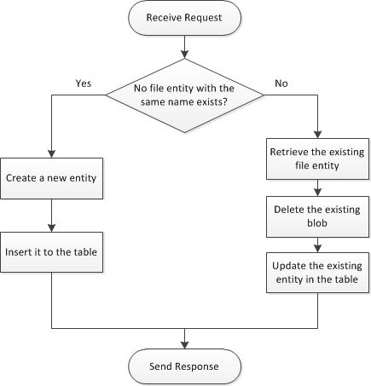

* WFWorkerRole/UpdateFilesList.xaml

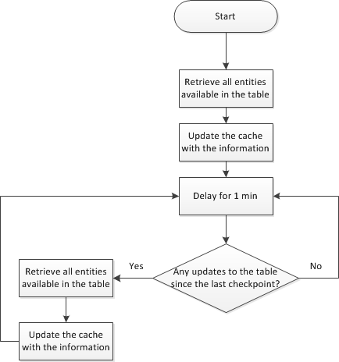

# Service Configurations

The sample solution entails the use of Windows Azure Storage Service and Windows Azure AppFabric Caching Service, and therefore requires manual configuration on both of these services.

## Configurations for Windows Azure Storage Service

**When running in the cloud**, storage activities will retrieve the storage connection string from Service Configuration of Windows Azure Project. If the project is going to be hosted on Windows Azure Platform, please follow the instructions below:

1. Open the sample solution with Microsoft Visual Studio.
2. If you don’t want the project to use local development storage, please configure the same storage connection string for UIWebRole, WFWebRole and WFWorkerRole. To do so, please select a role, and double click to open its service configuration window, and switch to “Settings” tab.
3. If the name of the configured storage connection string is different from the default one “Microsoft.WindowsAzure.Plugins.Diagnostics.ConnectionString”, you need to adjust storage activities (“ConfigurationName” property) in *WFWebRole/UploadService.xamlx* and *WFWorkerRole/UpdateFilesList.xaml* to use the name of the configured storage connection string.

**When running on-premises**, storage activities will retrieve the storage connection string from the project configuration file (App.config or Web.config). If you want to leverage Windows Azure Storage Service in normal projects rather than Windows Azure Project, please follow the instructions below:

1. Open the sample solution with Microsoft Visual Studio.
2. If you don’t want the project to use local development storage, please configure the same storage connection string for UIWebRole, WFWebRole and WFWorkerRole. To do so, please open App.config or Web.config file, and locate the “appSettings” section.
3. If the name of the configured storage connection string is different from the default one “Microsoft.WindowsAzure.Plugins.Diagnostics.ConnectionString”, you need to adjust storage activities (“ConfigurationName” property) in *WFWebRole/UploadService.xamlx* and *WFWorkerRole/UpdateFilesList.xaml* to use the name of the configured storage connection string.

Additional Information:

* [Create a Storage Account](http://msdn.microsoft.com/en-us/library/ff683668.aspx#createstorageaccount)
* [Manage connection strings for storage accounts](http://msdn.microsoft.com/en-us/library/hh369931.aspx#ConnectionStrings)

## Configurations for Windows Azure AppFabric Caching Service

No matter the application is running in the cloud or on-premises, caching activities will retrieve Caching Client Configuration from the project configuration file (App.config or Web.config). If you want to leverage Windows Azure AppFabric Caching Service in the workflow, please follow the instructions below:

1. Open the sample solution with Microsoft Visual Studio.
2. Please configure the same storage connection string for both UIWebRole and WFWorkerRole. To do so, please open App.config or Web.config file, and locate the “dataCacheClients” section.
3. If the name of the caching client configuration is different from the pre-defined one “default”, you need to adjust caching activities (“ConfigurationName” property) in *WFWorkerRole/UpdateFilesList.xaml* to use the name of the configured caching client configuration.

# Walkthrough

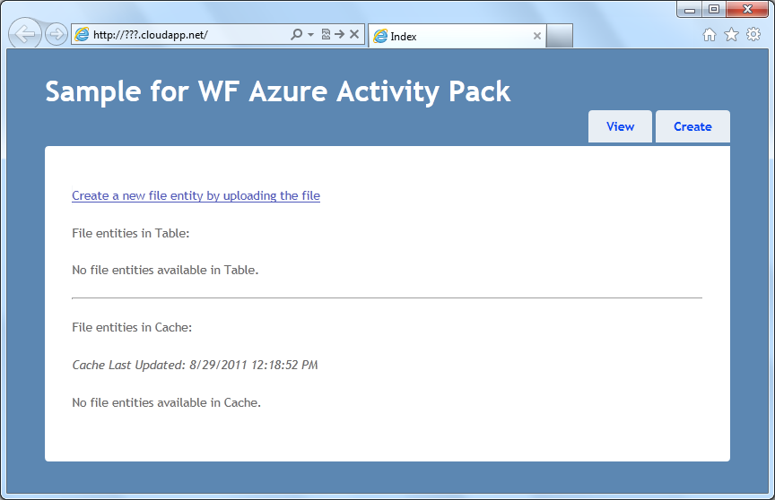

Click here to upload a file

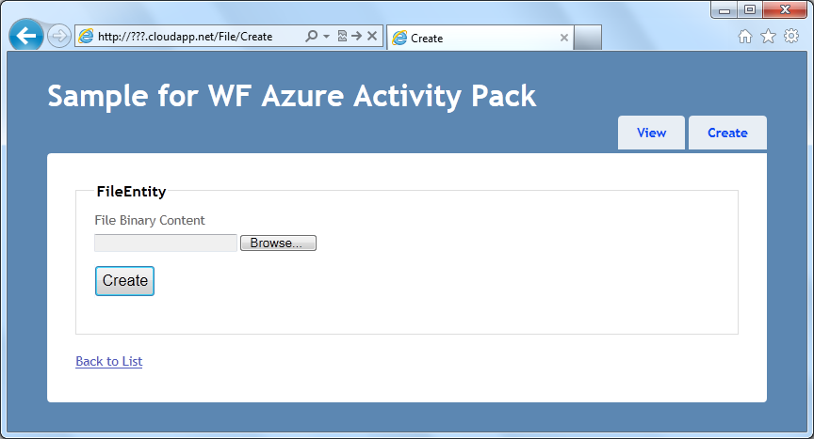

Choose a file for uploading

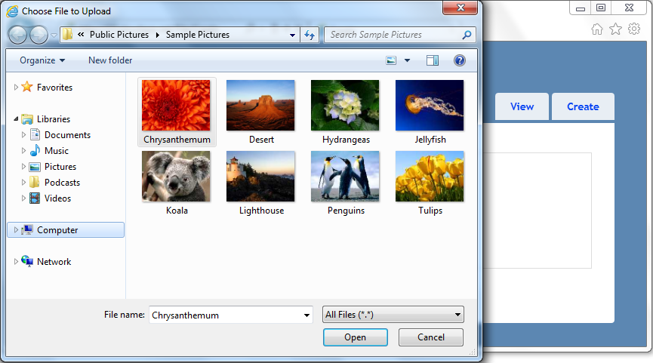

Choose a file

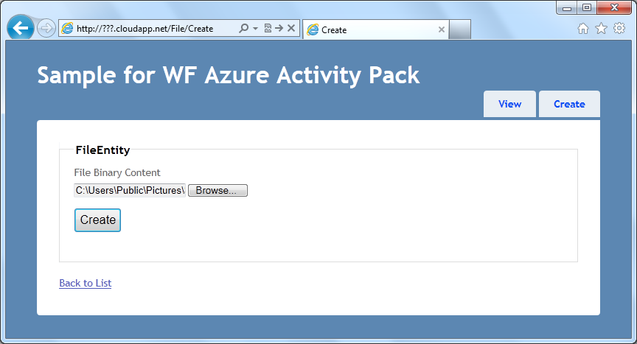

Click to begin uploading

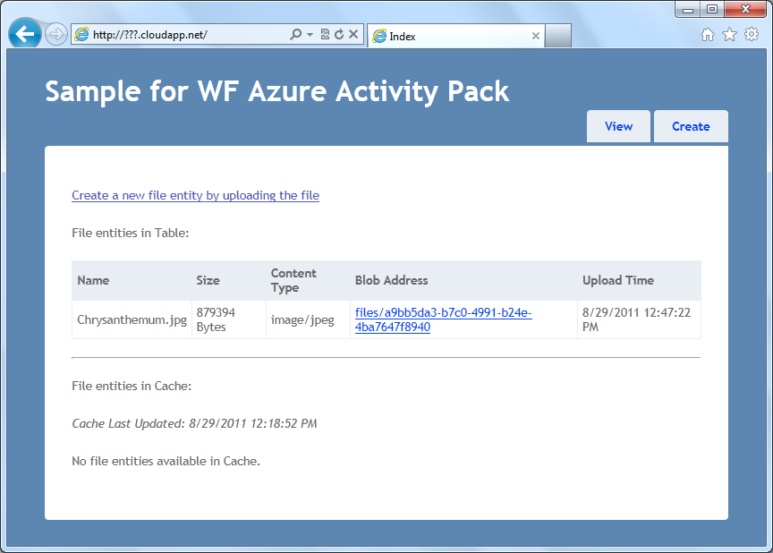

Cache is not up-to-date

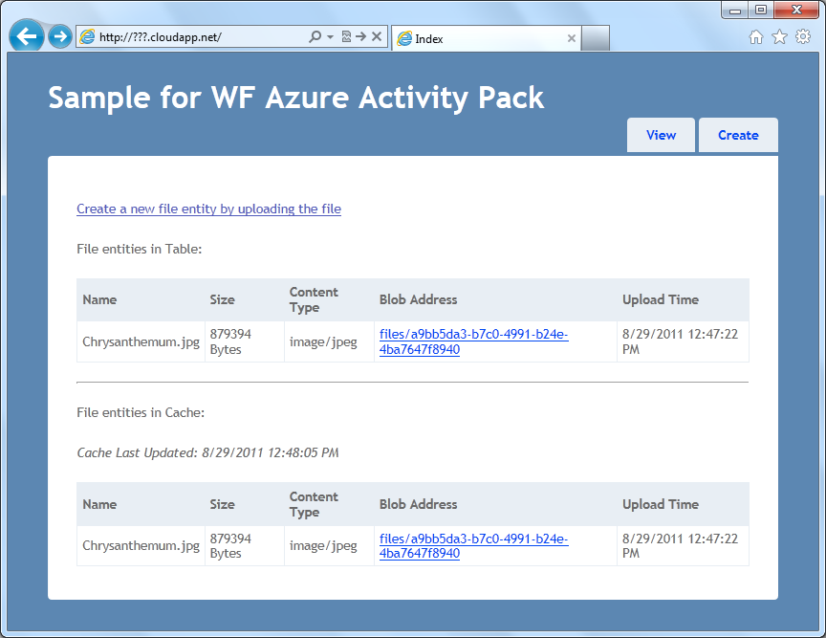

Cache is now up-to-date